**JavaScript Console Commands**

**After starting the Nodes and network setup**

**Steps:**

1. Setup the Geth JS Console

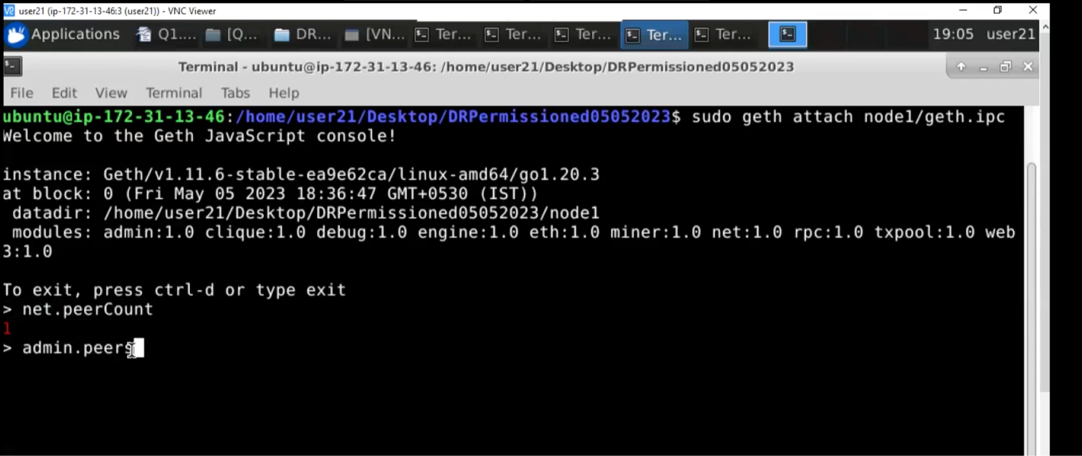

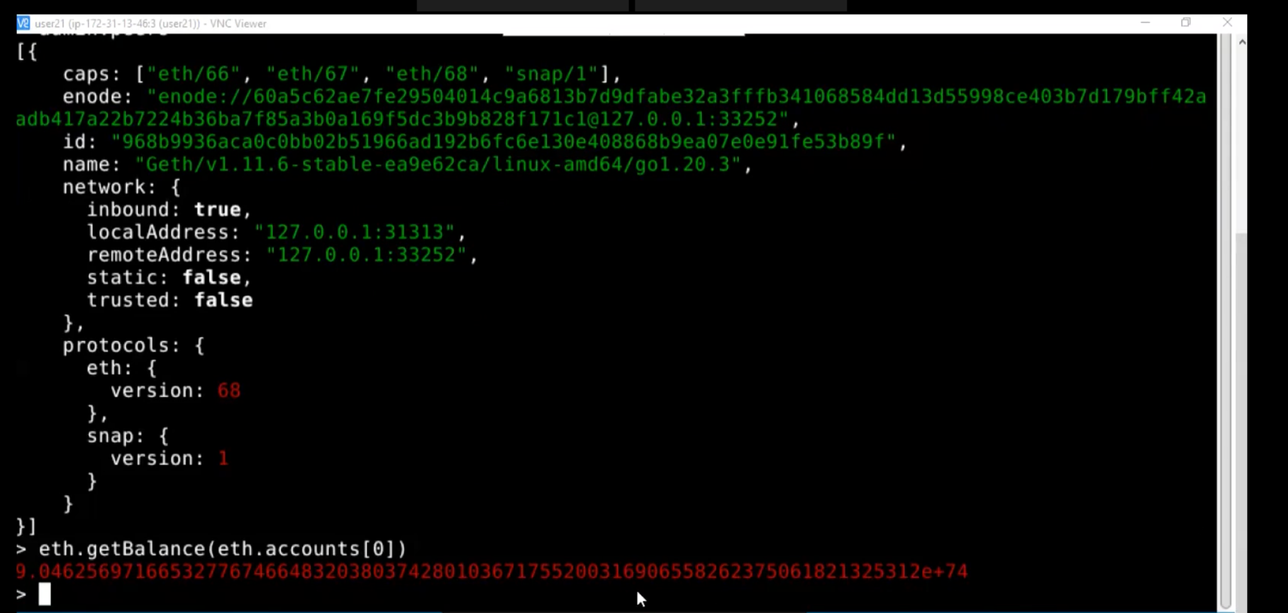

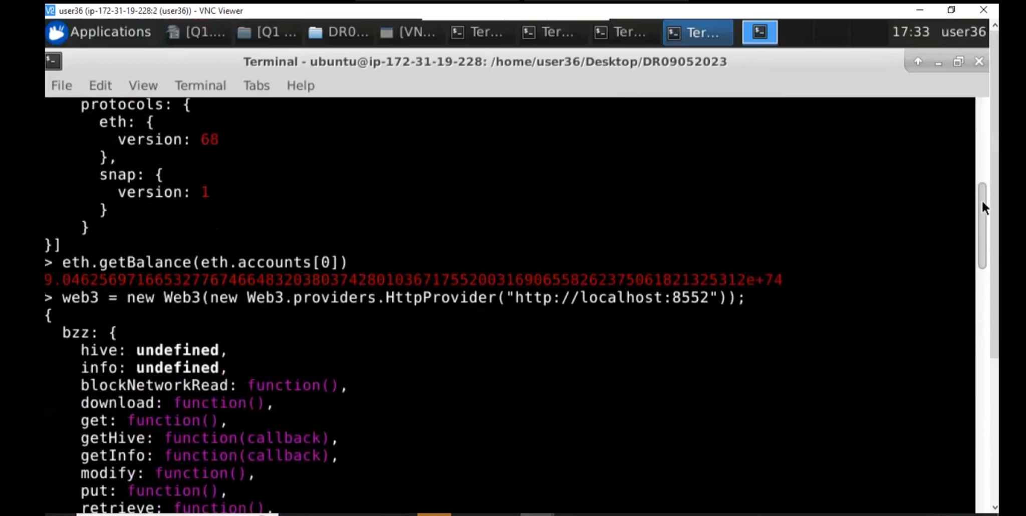

**Attach the Web3 Console**

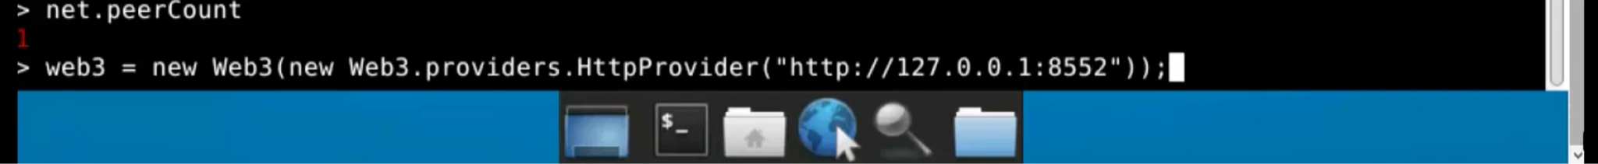

To make transactions, you need to unlock the personal account

**## Clef** (Initialize Clef)

Using Clef and Geth in synchronization, to verify and unlock the accounts for performing any further transactions

